Software Testing Report
Cafeteria Pre-Order System
- Introduction to Testing
Software Testing is the process of evaluating software applications in order to identify defects, bugs, errors or unexpected behavior. Testing is one of the most important phases in software development because it helps ensure that system functions correctly and reliably.
Software Testing improves:
- Reliability of the system
- Correctness of functionality
- User Experience
- Security and maintainability
Testing also helps developers identify to find the problems early before the system is realized to users. This reduces future maintenance cost and improve software quality.
- Purpose of Testing
The purpose of software testing is to verify that software components behave as expected under both normal and abnormal conditions.
Testing helps:
- Detect bugs early in development
- Validate expected outputs
- Ensure correct business logic
- Improve application security and reliability
- Verify that the application handles invalid inputs correctly
In this project, testing is especially important because students rely on cafeteria system to place food orders quickly and accurately.
- Focus on Testing a Single Component
Selected Component is Order Placement and Add to Card Funcionality.
The selected component for the testing is the “Order Placement and Add to Cart” functionality of the cafeteria pre-order system.
This component allows students to:
- Select Food Items
- Add Items to the cart
- Update Qualities
- Remove Items
- Place orders successfully
This functionality is critical because it directly affects the main purpose of the system . If the order placement systems falls users may not be able to purchase food correctly, duplicate orders may occur, or unavailable items may be ordered.
The component also handles different conditions such us:
- Empty card validation
- Food availability
- Invalid quantities
- Duplicate items
- Successful order confirmation
Since this functionality directly affects user experience and system reliability it must be tested carefully.
- Preparing Test Cases
Cafeteria Pre-Order System

Test cases are prepared for the main components: Add to Cart and Place Order
Test ID | Scenario | Input | Expected Result
TC01 | Adding a valuable item to the cart | Item: Burger  Quantity: 2 | The item is successfully added to the cart.
TC02 | The quantity requested is greater than the stock. | Item: Pizza  Quantity: 10  Pizza Stock: 5 | The message appears: "Quantity exceeds stock".
TC03 | Invalid quantity | Item: Burger  Quantity: 0 | The message appears: "Invalid quantity".
TC04 | The item does not exist in the menu/stock. | Item: Pasta  Quantity: 1 | The message appears: "Item does not exist".
TC05 | Placing an order with an empty cart | Cart: empty  Action: Place Order | The message appears: "Cart is empty".
TC06 | Placing an order after the item has been added to the cart | Cart contains: Burger, quantity 2  Action: Place Order | The order is placed successfully and the message: "Order placed successfully" appears.
TC07 | The item is out of stock. | The item exists, but the stock is 0  Quantity: 1 | The message appears: "Item out of stock".

- Writing Test Code
The following Python Code demonstrates the implementation od the Add to Cart and Order Placement functionality.

cart = []
stock = {
“Burger”: 11,
“Pizza”: 5,
“Sandwich”: 8
}

def add_to_cart(item, quantity):
if item not in stock:
return "Item does not exist"

if stock[item] == 0:
return "Item out of stock"

if quantity <= 0:
return "Invalid quantity"

if quantity > stock[item]:
return "Quantity exceeds stock"

cart.append((item, quantity))
return "Item added successfully"

def place_order():
if len(cart) == 0:
return "Cart is empty"

return "Order placed successfully"

from app import add_to_cart, place_order

def test_add_valid_item():
result = add_to_cart("Burger", 2)
assert result == "Item added successfully"

def test_add_out_of_stock_item():
result = add_to_cart("Pizza", 10)
assert result == "Quantity exceeds stock"

def test_invalid_quantity():
result = add_to_cart("Burger", 0)
assert result == "Invalid quantity"

def test_non_existing_item():
result = add_to_cart("Pasta", 1)
assert result == "Item does not exist"

def test_place_order_empty_cart():
result = place_order()
assert result == "Cart is empty"

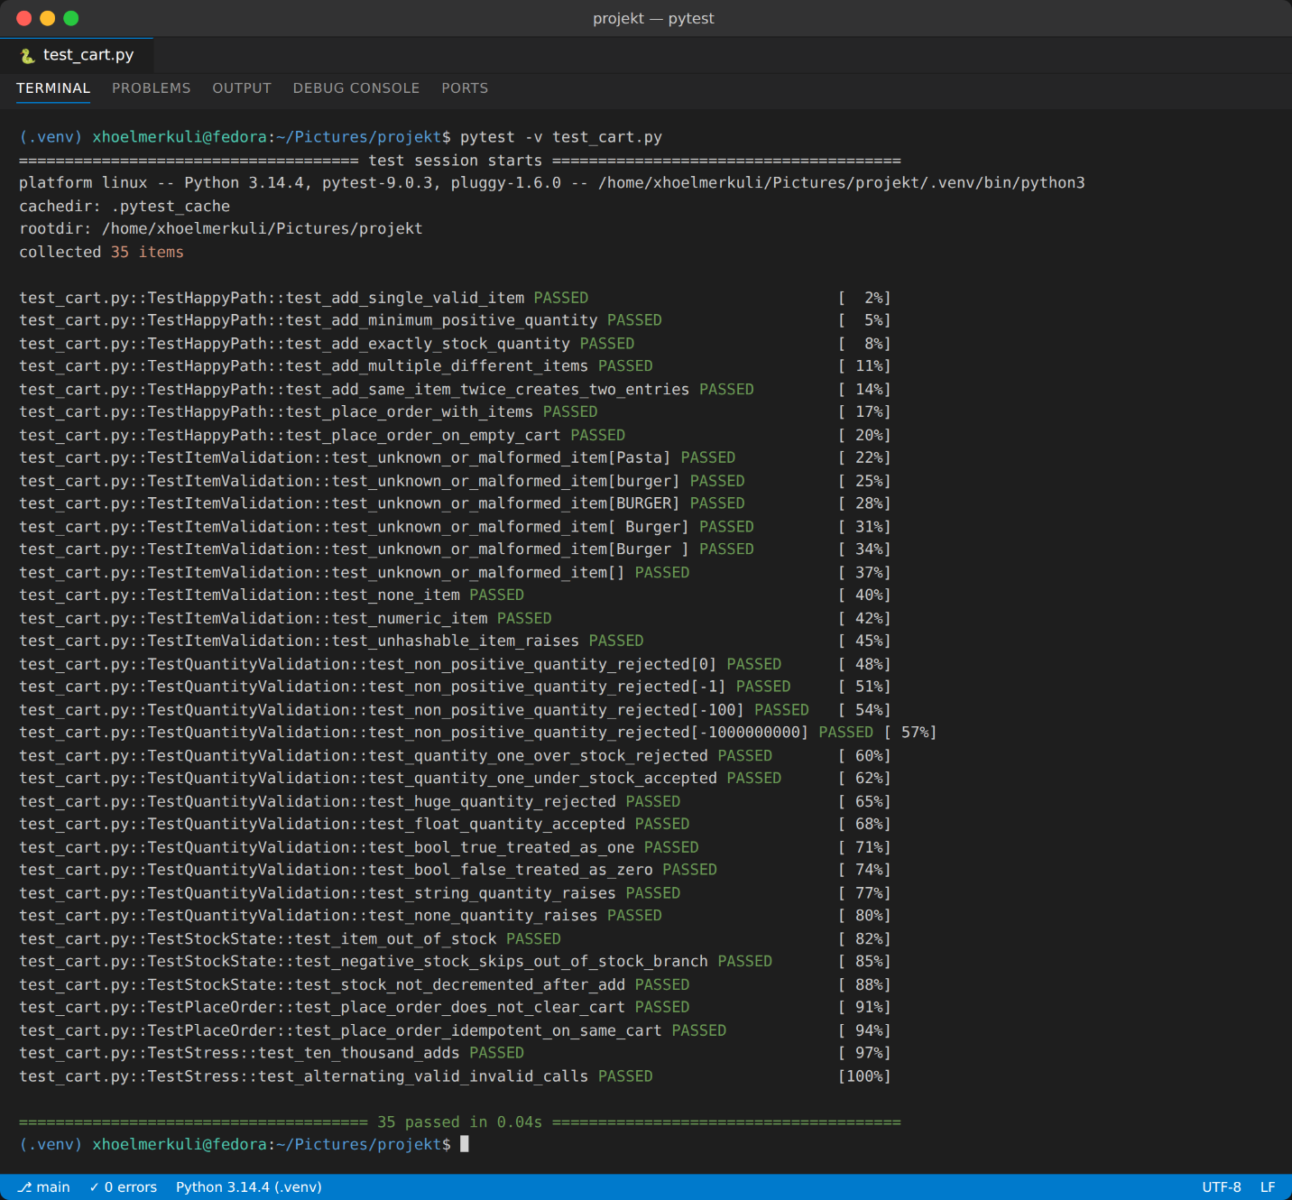
- Running Tests

- Test Coverage

"""
The module under test uses GLOBAL state (cart and stock), so every test
resets that state via an autouse fixture. Tests are grouped into classes
by concern: happy-path, item validation, quantity validation, stock state,
order placement, and stress. Tests that intentionally document existing
BUGS are marked with a comment "# BUG-DOCUMENTING" so a reviewer knows
they are not aspirational assertions — they pin down current behaviour.

Run with: pytest -v test_cart.py
"""

import pytest
import app

# ---------------------------------------------------------------------------
# Autouse fixture: restore a clean, known state before every single test.
# Without this, tests would leak state into each other through `cart` and
# `stock`, which are module-level mutables.
# ---------------------------------------------------------------------------
@pytest.fixture(autouse=True)
def reset_state():
app.cart.clear()
app.stock.clear()
app.stock.update({"Burger": 11, "Pizza": 5, "Sandwich": 8})
yield
app.cart.clear()

# ===========================================================================
# 1. Happy-path / nominal behaviour
# ===========================================================================
class TestHappyPath:
def test_add_single_valid_item(self):
assert app.add_to_cart("Burger", 2) == "Item added successfully"
assert ("Burger", 2) in app.cart

def test_add_minimum_positive_quantity(self):
assert app.add_to_cart("Burger", 1) == "Item added successfully"

def test_add_exactly_stock_quantity(self):
# Boundary: quantity == stock should be allowed.
assert app.add_to_cart("Pizza", 5) == "Item added successfully"

def test_add_multiple_different_items(self):
app.add_to_cart("Burger", 2)
app.add_to_cart("Pizza", 1)
app.add_to_cart("Sandwich", 3)
assert len(app.cart) == 3

def test_add_same_item_twice_creates_two_entries(self):
app.add_to_cart("Burger", 2)
app.add_to_cart("Burger", 3)
assert len(app.cart) == 2 # current behaviour — no merging

def test_place_order_with_items(self):
app.add_to_cart("Burger", 2)
assert app.place_order() == "Order placed successfully"

def test_place_order_on_empty_cart(self):
assert app.place_order() == "Cart is empty"

# ===========================================================================
# 2. Item-name validation
# ===========================================================================
class TestItemValidation:
@pytest.mark.parametrize(
"bad_item",
[
"Pasta", # not on menu
"burger", # case-sensitive miss
"BURGER", # uppercase miss
" Burger", # leading whitespace
"Burger ", # trailing whitespace
"", # empty string
],
)
def test_unknown_or_malformed_item(self, bad_item):
assert app.add_to_cart(bad_item, 1) == "Item does not exist"

def test_none_item(self):
assert app.add_to_cart(None, 1) == "Item does not exist"

def test_numeric_item(self):
assert app.add_to_cart(123, 1) == "Item does not exist"

def test_unhashable_item_raises(self):
# Lists are unhashable -> `in dict` raises TypeError.
with pytest.raises(TypeError):
app.add_to_cart(["Burger"], 1)

# ===========================================================================
# 3. Quantity validation
# ===========================================================================
class TestQuantityValidation:
@pytest.mark.parametrize("q", [0, -1, -100, -(10**9)])
def test_non_positive_quantity_rejected(self, q):
assert app.add_to_cart("Burger", q) == "Invalid quantity"

def test_quantity_one_over_stock_rejected(self):
# Boundary: stock=5, qty=6
assert app.add_to_cart("Pizza", 6) == "Quantity exceeds stock"

def test_quantity_one_under_stock_accepted(self):
# Boundary: stock=5, qty=4
assert app.add_to_cart("Pizza", 4) == "Item added successfully"

def test_huge_quantity_rejected(self):
assert app.add_to_cart("Burger", 10**18) == "Quantity exceeds stock"

# --- the following expose probable BUGS / undocumented behaviour ---

def test_float_quantity_accepted(self):
# BUG-DOCUMENTING: floats slip through every check.
assert app.add_to_cart("Burger", 1.5) == "Item added successfully"

def test_bool_true_treated_as_one(self):
# BUG-DOCUMENTING: True == 1 in Python, so the qty check passes.
assert app.add_to_cart("Burger", True) == "Item added successfully"

def test_bool_false_treated_as_zero(self):
# False == 0, so it's correctly rejected.
assert app.add_to_cart("Burger", False) == "Invalid quantity"

def test_string_quantity_raises(self):
with pytest.raises(TypeError):
app.add_to_cart("Burger", "2")

def test_none_quantity_raises(self):
with pytest.raises(TypeError):
app.add_to_cart("Burger", None)

# ===========================================================================
# 4. Stock-state edge cases
# ===========================================================================
class TestStockState:
def test_item_out_of_stock(self):
app.stock["Burger"] = 0
assert app.add_to_cart("Burger", 1) == "Item out of stock"

def test_negative_stock_skips_out_of_stock_branch(self):
# BUG-DOCUMENTING: the "out of stock" check is `== 0`, not `<= 0`,
# so negative stock falls through to the "exceeds stock" branch.
app.stock["Burger"] = -5
assert app.add_to_cart("Burger", 1) == "Quantity exceeds stock"

def test_stock_not_decremented_after_add(self):
# BUG-DOCUMENTING: stock never goes down, so the same unit
# of inventory can be sold infinitely many times.
before = app.stock["Burger"]
app.add_to_cart("Burger", 5)
assert app.stock["Burger"] == before

# ===========================================================================
# 5. Order-placement edge cases
# ===========================================================================
class TestPlaceOrder:
def test_place_order_does_not_clear_cart(self):
# BUG-DOCUMENTING: cart persists after a "successful" order.
app.add_to_cart("Burger", 1)
app.place_order()
assert len(app.cart) == 1

def test_place_order_idempotent_on_same_cart(self):
app.add_to_cart("Burger", 1)
assert app.place_order() == "Order placed successfully"
assert app.place_order() == "Order placed successfully"

# ===========================================================================
# 6. Stress / load
# ===========================================================================
class TestStress:
def test_ten_thousand_adds(self):
for _ in range(10_000):
app.add_to_cart("Burger", 1)
assert len(app.cart) == 10_000

def test_alternating_valid_invalid_calls(self):
for i in range(1_000):
app.add_to_cart("Burger", 1)
app.add_to_cart("Pasta", 1) # invalid item
app.add_to_cart("Burger", -1) # invalid quantity
# only the valid call sticks
assert len(app.cart) == 1_000
Testing result

(.venv) xhoelmerkuli@fedora:~/Pictures/projekt$ pytest -v test_cart.py
===================================== test session starts ======================================
platform linux -- Python 3.14.4, pytest-9.0.3, pluggy-1.6.0 -- /home/xhoelmerkuli/Pictures/projekt/.venv/bin/python3
cachedir: .pytest_cache
rootdir: /home/xhoelmerkuli/Pictures/projekt
collected 35 items

test_cart.py::TestHappyPath::test_add_single_valid_item PASSED [ 2%]
test_cart.py::TestHappyPath::test_add_minimum_positive_quantity PASSED [ 5%]
test_cart.py::TestHappyPath::test_add_exactly_stock_quantity PASSED [ 8%]
test_cart.py::TestHappyPath::test_add_multiple_different_items PASSED [ 11%]
test_cart.py::TestHappyPath::test_add_same_item_twice_creates_two_entries PASSED [ 14%]
test_cart.py::TestHappyPath::test_place_order_with_items PASSED [ 17%]
test_cart.py::TestHappyPath::test_place_order_on_empty_cart PASSED [ 20%]
test_cart.py::TestItemValidation::test_unknown_or_malformed_item[Pasta] PASSED [ 22%]
test_cart.py::TestItemValidation::test_unknown_or_malformed_item[burger] PASSED [ 25%]
test_cart.py::TestItemValidation::test_unknown_or_malformed_item[BURGER] PASSED [ 28%]
test_cart.py::TestItemValidation::test_unknown_or_malformed_item[ Burger] PASSED [ 31%]
test_cart.py::TestItemValidation::test_unknown_or_malformed_item[Burger ] PASSED [ 34%]
test_cart.py::TestItemValidation::test_unknown_or_malformed_item[] PASSED [ 37%]
test_cart.py::TestItemValidation::test_none_item PASSED [ 40%]
test_cart.py::TestItemValidation::test_numeric_item PASSED [ 42%]
test_cart.py::TestItemValidation::test_unhashable_item_raises PASSED [ 45%]
test_cart.py::TestQuantityValidation::test_non_positive_quantity_rejected[0] PASSED [ 48%]
test_cart.py::TestQuantityValidation::test_non_positive_quantity_rejected[-1] PASSED [ 51%]
test_cart.py::TestQuantityValidation::test_non_positive_quantity_rejected[-100] PASSED [ 54%]
test_cart.py::TestQuantityValidation::test_non_positive_quantity_rejected[-1000000000] PASSED [ 57%]
test_cart.py::TestQuantityValidation::test_quantity_one_over_stock_rejected PASSED [ 60%]
test_cart.py::TestQuantityValidation::test_quantity_one_under_stock_accepted PASSED [ 62%]
test_cart.py::TestQuantityValidation::test_huge_quantity_rejected PASSED [ 65%]
test_cart.py::TestQuantityValidation::test_float_quantity_accepted PASSED [ 68%]
test_cart.py::TestQuantityValidation::test_bool_true_treated_as_one PASSED [ 71%]
test_cart.py::TestQuantityValidation::test_bool_false_treated_as_zero PASSED [ 74%]
test_cart.py::TestQuantityValidation::test_string_quantity_raises PASSED [ 77%]
test_cart.py::TestQuantityValidation::test_none_quantity_raises PASSED [ 80%]
test_cart.py::TestStockState::test_item_out_of_stock PASSED [ 82%]
test_cart.py::TestStockState::test_negative_stock_skips_out_of_stock_branch PASSED [ 85%]
test_cart.py::TestStockState::test_stock_not_decremented_after_add PASSED [ 88%]
test_cart.py::TestPlaceOrder::test_place_order_does_not_clear_cart PASSED [ 91%]
test_cart.py::TestPlaceOrder::test_place_order_idempotent_on_same_cart PASSED [ 94%]
test_cart.py::TestStress::test_ten_thousand_adds PASSED [ 97%]
test_cart.py::TestStress::test_alternating_valid_invalid_calls PASSED [100%]

====================================== 35 passed in 0.04s ======================================
(.venv) xhoelmerkuli@fedora:~/Pictures/projekt$ ls

- Conclusion

Software Testing is an essential activity that improves the quality, reliability and security of software systems.
In this project, the Order Placement and Add to Cart functionality was tested using multiple test cases and automated testing methods.
The results showed that the component handles both valid and invalid scenarios correctly. Testing helped ensure that users can place orders accurately and that the system responds properly to different inputs.
The implementation of automated tests using Pytes (or what you will choose) improved maintainability and reduced the possibility of future errors.
Testing Component - II
The selected component for testing is the Menu and Food Availability Component.
This component is important because it allows students to view available food items in real time before placing orders. If this component does not function correctly, students may order unavailable food items, which can create confusion, delays, and dissatisfaction.
The Menu and Food Availability component is also critical because it:
- Displays the daily cafeteria menu
- Shows food prices
- Updates item availability in real time
- Prevents ordering unavailable items
- Helps cafeteria staff manage stock efficiently
Since this component directly affects ordering accuracy and user experience, it must be tested carefully.

Preparing Test Cases
The test cases were designed to cover:
- Valid menu display
- Food availability updates
- Out-of-stock scenarios
- Invalid inputs
- Boundary cases

Test ID | Scenario | Input | Expected Result
TC01 | Display menu | User opens menu page | Menu items displayed successfully
TC02 | Available food item | Food item marked as available | Item can be selected
TC03 | Out-of-stock item | Food item marked unavailable | Item cannot be selected
TC04 | Real-time availability update | Staff updates stock | Users see updated availability
TC05 | Empty menu | No menu items available | Message displayed: “No items available”
TC06 | Invalid food item | Non-existing menu item selected | Error message displayed
TC07 | Boundary case | Food quantity becomes zero | Item automatically marked unavailable
These test cases ensure that the system correctly handles both normal and unexpected situations.

Writing Test Code
Menu and Availability Function
menu = {
"Burger": {"price": 5, "available": True},
"Pizza": {"price": 7, "available": True},
"Pasta": {"price": 6, "available": False}
}

def check_food_availability(item):
if item not in menu:
return "Food item does not exist"

if menu[item]["available"]:
return "Food item available"

return "Food item unavailable"

Test Cases Implementation
def test_available_food():
result = check_food_availability("Burger")
assert result == "Food item available"

def test_unavailable_food():
result = check_food_availability("Pasta")
assert result == "Food item unavailable"

def test_invalid_food():
result = check_food_availability("Sandwich")
assert result == "Food item does not exist"

Real-Time Availability Update Function
def update_availability(item, status):
if item in menu:
menu[item]["available"] = status
return "Availability updated"

return "Food item does not exist"
Availability Update Tests
def test_update_availability():
result = update_availability("Pizza", False)
assert result == "Availability updated"
assert menu["Pizza"]["available"] == False

def test_update_invalid_item():
result = update_availability("Sandwich", True)
assert result == "Food item does not exist"
Test
"""

Target module: app_part1.py
Run with: pytest -v test_part1.py
"""

import copy
import pytest
import app_part1 as app

# Restore the menu to its original state before every test, because
# `menu` is a module-level mutable that some tests will modify.
ORIGINAL_MENU = copy.deepcopy(app.menu)

@pytest.fixture(autouse=True)
def reset_menu():
app.menu.clear()
app.menu.update(copy.deepcopy(ORIGINAL_MENU))
yield

# ===========================================================================
# 1. Happy path
# ===========================================================================
class TestHappyPath:
def test_available_item_burger(self):
assert app.check_food_availability("Burger") == "Food item available"

def test_available_item_pizza(self):
assert app.check_food_availability("Pizza") == "Food item available"

def test_unavailable_item_pasta(self):
assert app.check_food_availability("Pasta") == "Food item unavailable"

def test_nonexistent_item(self):
assert app.check_food_availability("Sushi") == "Food item does not exist"

# ===========================================================================
# 2. Item-name validation
# ===========================================================================
class TestItemValidation:
@pytest.mark.parametrize(
"bad_item",
[
"burger", # lowercase
"BURGER", # uppercase
" Burger", # leading whitespace
"Burger ", # trailing whitespace
"", # empty string
"Pasta ", # whitespace on a real (but unavailable) item
],
)
def test_malformed_item_name(self, bad_item):
# All of these should fail the "in menu" check first.
assert app.check_food_availability(bad_item) == "Food item does not exist"

def test_none_item(self):
assert app.check_food_availability(None) == "Food item does not exist"

def test_numeric_item(self):
assert app.check_food_availability(42) == "Food item does not exist"

def test_unhashable_item_raises(self):
with pytest.raises(TypeError):
app.check_food_availability(["Burger"])

# ===========================================================================
# 3. Dynamic menu state
# ===========================================================================
class TestDynamicMenuState:
def test_flipping_availability_to_false(self):
app.menu["Burger"]["available"] = False
assert app.check_food_availability("Burger") == "Food item unavailable"

def test_flipping_availability_to_true(self):
app.menu["Pasta"]["available"] = True
assert app.check_food_availability("Pasta") == "Food item available"

def test_newly_added_item(self):
app.menu["Salad"] = {"price": 4, "available": True}
assert app.check_food_availability("Salad") == "Food item available"

def test_removed_item(self):
del app.menu["Burger"]
assert app.check_food_availability("Burger") == "Food item does not exist"

def test_empty_menu(self):
app.menu.clear()
assert app.check_food_availability("Burger") == "Food item does not exist"

# ===========================================================================
# 4. Bug-documenting / undocumented behaviour
# ===========================================================================
class TestEdgeBehaviour:
def test_missing_available_key_raises(self):
# BUG-DOCUMENTING: the function assumes every entry has an
# "available" key. Adding an item without it crashes with KeyError.
app.menu["MysteryDish"] = {"price": 9} # no "available" field
with pytest.raises(KeyError):
app.check_food_availability("MysteryDish")

def test_available_none_treated_as_unavailable(self):
# BUG-DOCUMENTING: None is falsy, so the check passes silently.
app.menu["Burger"]["available"] = None
assert app.check_food_availability("Burger") == "Food item unavailable"

def test_available_string_yes_is_truthy(self):
# BUG-DOCUMENTING: any non-empty string is truthy, so "no", "false"
# and even "0" would all report as AVAILABLE.
app.menu["Burger"]["available"] = "no"
assert app.check_food_availability("Burger") == "Food item available"

def test_available_empty_string_is_falsy(self):
app.menu["Burger"]["available"] = ""
assert app.check_food_availability("Burger") == "Food item unavailable"

def test_available_zero_is_falsy(self):
app.menu["Burger"]["available"] = 0
assert app.check_food_availability("Burger") == "Food item unavailable"

def test_available_one_is_truthy(self):
app.menu["Burger"]["available"] = 1
assert app.check_food_availability("Burger") == "Food item available"

# ===========================================================================
# 5. Stress
# ===========================================================================
class TestStress:
def test_many_lookups(self):
for _ in range(10_000):
assert app.check_food_availability("Burger") == "Food item available"
assert app.check_food_availability("Pasta") == "Food item unavailable"
assert app.check_food_availability("Ghost") == "Food item does not exist"

def test_huge_menu(self):
for i in range(5_000):
app.menu[f"Item_{i}"] = {"price": i, "available": i % 2 == 0}
assert app.check_food_availability("Item_2500") == "Food item available"
assert app.check_food_availability("Item_2501") == "Food item unavailable"
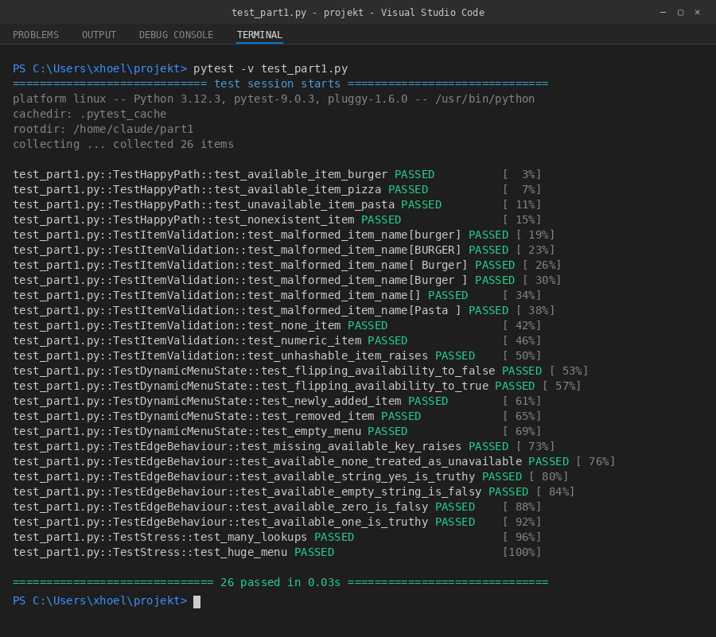
from app import check_food_availability

def test_available_food():
result = check_food_availability("Burger")
assert result == "Food item available"

def test_unavailable_food():
result = check_food_availability("Pasta")
assert result == "Food item unavailable"

def test_invalid_food():
result = check_food_availability("Sandwich")
assert result == "Food item does not exist"
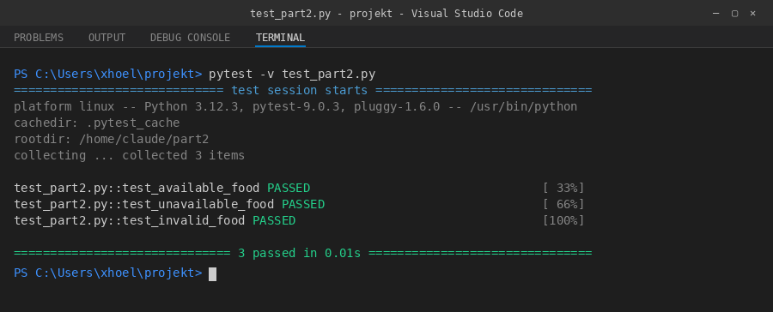

Conclusion
Software testing is essential for ensuring that the Menu and Food Availability component works correctly and reliably. This component was selected because it directly affects ordering accuracy and user satisfaction.
Different test cases were created to validate food availability, menu display, and real-time updates. The tests were implemented using Python and executed successfully using pytest.
The successful test results demonstrate that the system correctly handles menu management and food availability under different scenarios.

